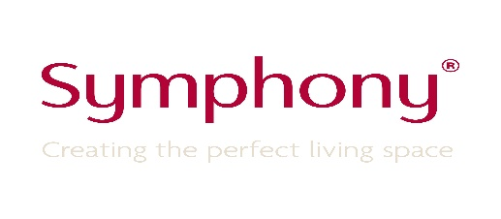

Internal Vacancy

Post Reference: VO3022

Department: IT

Post Title: Senior Developer

We have an exciting opportunity for somebody to join one of our existing scrum teams. You and your team will be working towards transforming and innovating our entire suite of applications that support the business and our customers.
We are looking for an enthusiastic and highly motivated individual with an eye for quality, a thirst for learning and a keen focus on opportunities for improvement.
Strong communication skills are a must, as you will be working closely with the business analyst and key stakeholders to understand their vision and turn it in to valuable solutions.

Essential skills:
C#
ASP.NET
MVC
T-SQL, SQL Server
Entity Framework
Web API, REST
Dependency injection
JavaScript
A good understanding of SOLID principles and design patterns
Unit testing (TDD)
A solid grounding in software design

One or more of the following would be beneficial:
.NET Core
Experience working with Microservices
Knowledge of PHP, Oracle, PL-SQL
Team City
Octopus Deploy
Jira
Experience writing automated UI tests, particularly selenium

If you are interested in this position, then please email your CV and covering letter to recruitment@symphony-group.co.uk. by Friday 17th May 2019.

Please quote the vacancy reference number on all correspondence.

